Methodology
Participants
Stimuli
Thirty-two di- and trisyllabic Spanish nouns, selected from the MultiPic database (Duñabeitia et al., 2018) are employed in this picture naming task (Table 1). The stimuli are controlled for different psycholinguistic variables (Duchon et al., 2013): cognate status with Basque and English (noncognates), logarithmic frequency (mean = 4.09), mean bigram frequency (mean = 30304,25), number of letters (4 – 7), number of phonemes (4 – 7), number of syllables, percentage of bimanual transitions (calculated manually by the author, mean = 43.69), and semantic category (animal, body part, clothes, food, job, object, place). The main aim was to include a similar number of stimuli for each semantic category, but in order to manage to control for the previous variables as well, some semantic categories (object, animal) include more stimuli than others (food). Regarding percentage of bimanual transitions and mean bigram frequency, we opted for a relatively homogenous distribution of the values (Figures 1 and 2, respectively).
Since the main task is picture naming, each item is presented in the form of a picture. Pictures depicting the target words are controlled for imageability (mean = 6.06) (Duchon et al., 2013), visual complexity (mean = 2.37), and name agreement (≥ 90) measures (Duñabeitia et al., 2018). Three pictures did not include information about imageability, but were included nevertheless.

Animal | Body part | Clothes | Food | Job | Object | Place
pavo | espalda | traje | manzana | cazador | muñeca | iglesia
conejo | mano | falda | fresa | pintor | vaso | baño
caracol | oreja | guante | miel | cartero | aguja | puente
pulpo | pierna | camisa |  | bombero | regalo | granja
vaca |  |  |  |  | goma
cerdo |  |  |  |  | taza
 |  |  |  |  | cuerda
Table 1. Spanish nouns per semantic category included in the present research.

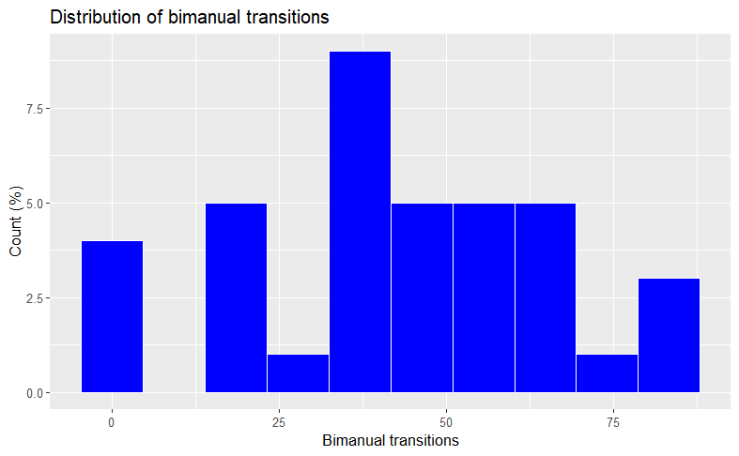
Figure 1. Distribution of bimanual transitions (%).

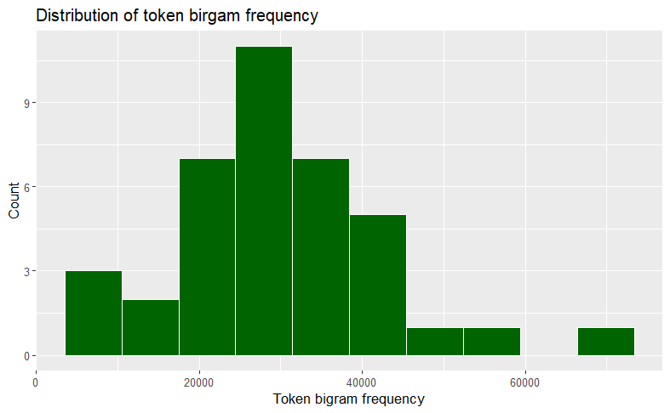
Figure 2. Distribution of mean token bigram frequency.

Experimental list
For the creation of the experimental list, we used the Euler package in R (Larsson, 2022) to obtain four different balanced sequences of the four conditions of interest: repeat type, repeat speak (Figure 3) and switch type to speak, switch speak to type (Figure 4). Every sequence consists of eight trial pairs (the second trial in each pair is the target one) and eight filler trials (Table 2). This sums up to 64 trials (target = 32) per sequence. We further reordered those sequences for a total of four different orders per sequence. We ensured that each pair will appear once in all conditions among those four sequence orders. We further controlled that not more than three items of the same modality nor more than three trial pairs appear consecutively. Also, unless in a trial pair, the same picture should not be repeated.
We created four sets of eight different pictures (N = 32). Each set of pictures corresponds to one of the four sequencies (Table 3). Throughout the list, we added 24 extra filler trials balanced across modality sequence and response modality to prevent modality repetition, but also as trials at the beginning of the overall list and at the beginning of blocks. For those extra trials, we added six more pictures (espejo, cadena, escoba, tronco, tenedor, columna). These trials will not be included in the final analyses.
The final list consisted of four parts (one per sequence), where each part consisted of 102 trials (32 target trials). These four parts we mixed in order to create three more experimental lists.
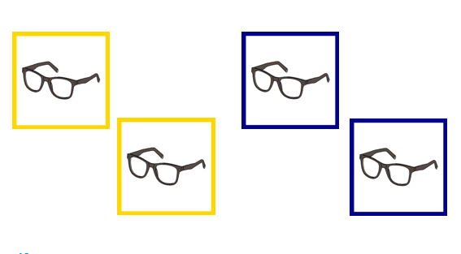
Figure 3. Experimental conditions: repeat speak (left), repeat type (right).
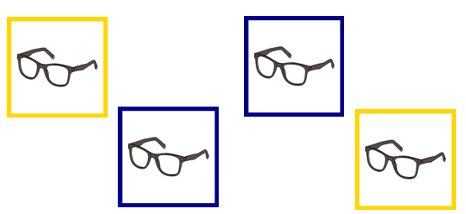
Figure 4. Experimental conditions: switch speak to type (left), switch type to speak (right).
Set | Sequence | Modality | Target | Rep_Sw | Order1 | Order2 | Order3 | Order4
1 | 2 | speak | NT |  | Stim1 | Stim4 | Stim7 | Stim5
1 | 2 | speak | T | repeat | Stim1 | Stim4 | Stim7 | Stim5
1 | 2 | speak | NT |  | Stim2 | Stim3 | Stim6 | Stim8
1 | 2 | speak | T | repeat | Stim2 | Stim3 | Stim6 | Stim8
1 | 2 | speak | NT |  | Stim3 | Stim6 | Stim8 | Stim7
1 | 1 | type | T | switch | Stim3 | Stim6 | Stim8 | Stim7
1 | 1 | type | NT |  | Stim4 | Stim2 | Stim1 | Stim3
1 | 2 | speak | T | switch | Stim4 | Stim2 | Stim1 | Stim3
1 | 2 | speak | NT |  | Stim5 | Stim1 | Stim4 | Stim2
1 | 1 | type | T | switch | Stim5 | Stim1 | Stim4 | Stim2
1 | 1 | type | NT |  | Stim6 | Stim8 | Stim2 | Stim4
1 | 1 | type | T | repeat | Stim6 | Stim8 | Stim2 | Stim4
1 | 1 | type | NT |  | Stim7 | Stim5 | Stim3 | Stim1
1 | 1 | type | T | repeat | Stim7 | Stim5 | Stim3 | Stim1
1 | 1 | type | NT |  | Stim8 | Stim7 | Stim5 | Stim6
1 | 2 | speak | T | switch | Stim8 | Stim7 | Stim5 | Stim6
2 | 1 | type | NT |  | Stim1 | Stim5 | Stim7 | Stim8
2 | 1 | type | T | repeat | Stim1 | Stim5 | Stim7 | Stim8
2 | 1 | type | NT |  | Stim2 | Stim3 | Stim6 | Stim4
2 | 1 | type | T | repeat | Stim2 | Stim3 | Stim6 | Stim4
2 | 1 | type | NT |  | Stim3 | Stim1 | Stim4 | Stim6
2 | 2 | speak | T | switch | Stim3 | Stim1 | Stim4 | Stim6
2 | 2 | speak | NT |  | Stim4 | Stim7 | Stim5 | Stim2
2 | 1 | type | T | switch | Stim4 | Stim7 | Stim5 | Stim2
2 | 1 | type | NT |  | Stim5 | Stim2 | Stim8 | Stim7
2 | 2 | speak | T | switch | Stim5 | Stim2 | Stim8 | Stim7
2 | 2 | speak | NT |  | Stim6 | Stim4 | Stim2 | Stim3
2 | 2 | speak | T | repeat | Stim6 | Stim4 | Stim2 | Stim3
2 | 2 | speak | NT |  | Stim7 | Stim8 | Stim1 | Stim5
2 | 2 | speak | T | repeat | Stim7 | Stim8 | Stim1 | Stim5
2 | 2 | speak | NT |  | Stim8 | Stim6 | Stim3 | Stim1
2 | 1 | type | T | switch | Stim8 | Stim6 | Stim3 | Stim1
3 | 1 | type | NT |  | Stim1 | Stim6 | Stim4 | Stim5
3 | 2 | speak | T | switch | Stim1 | Stim6 | Stim4 | Stim5
3 | 2 | speak | NT |  | Stim2 | Stim4 | Stim7 | Stim1
3 | 1 | type | T | switch | Stim2 | Stim4 | Stim7 | Stim1
3 | 1 | type | NT |  | Stim3 | Stim8 | Stim2 | Stim7
3 | 2 | speak | T | switch | Stim3 | Stim8 | Stim2 | Stim7
3 | 2 | speak | NT |  | Stim4 | Stim7 | Stim6 | Stim3
3 | 2 | speak | T | repeat | Stim4 | Stim7 | Stim6 | Stim3
3 | 2 | speak | NT |  | Stim5 | Stim1 | Stim8 | Stim2
3 | 2 | speak | T | repeat | Stim5 | Stim1 | Stim8 | Stim2
3 | 2 | speak | NT |  | Stim6 | Stim3 | Stim5 | Stim8
3 | 1 | type | T | switch | Stim6 | Stim3 | Stim5 | Stim8
3 | 1 | type | NT |  | Stim7 | Stim5 | Stim3 | Stim6
3 | 1 | type | T | repeat | Stim7 | Stim5 | Stim3 | Stim6
3 | 1 | type | NT |  | Stim8 | Stim2 | Stim1 | Stim4
3 | 1 | type | T | repeat | Stim8 | Stim2 | Stim1 | Stim4
4 | 1 | type | NT |  | Stim1 | Stim3 | Stim4 | Stim6
4 | 1 | type | T | repeat | Stim1 | Stim3 | Stim4 | Stim6
4 | 1 | type | NT |  | Stim2 | Stim8 | Stim6 | Stim3
4 | 2 | speak | T | switch | Stim2 | Stim8 | Stim6 | Stim3
4 | 2 | speak | NT |  | Stim3 | Stim4 | Stim2 | Stim5
4 | 2 | speak | T | repeat | Stim3 | Stim4 | Stim2 | Stim5
4 | 2 | speak | NT |  | Stim4 | Stim2 | Stim5 | Stim1
4 | 1 | type | T | switch | Stim4 | Stim2 | Stim5 | Stim1
4 | 1 | type | NT |  | Stim5 | Stim7 | Stim1 | Stim4
4 | 2 | speak | T | switch | Stim5 | Stim7 | Stim1 | Stim4
4 | 2 | speak | NT |  | Stim6 | Stim1 | Stim8 | Stim7
4 | 2 | speak | T | repeat | Stim6 | Stim1 | Stim8 | Stim7
4 | 2 | speak | NT |  | Stim7 | Stim6 | Stim3 | Stim8
4 | 1 | type | T | switch | Stim7 | Stim6 | Stim3 | Stim8
4 | 1 | type | NT |  | Stim8 | Stim5 | Stim7 | Stim2
4 | 1 | type | T | repeat | Stim8 | Stim5 | Stim7 | Stim2
Table 2. Experimental list for picture naming task with response modality switch.

Stimulus | Set1 | Set2 | Set3 | Set4
Stim1 | puente | pintor | guante | vaca
Stim2 | fresa | caracol | miel | baño
Stim3 | traje | mano | cartero | pierna
Stim4 | muñeca | cuerda | aguja | taza
Stim5 | pavo | granja | oreja | camisa
Stim6 | cazador | manzana | goma | regalo
Stim7 | vaso | cerdo | conejo | bombero
Stim8 | espalda | falda | iglesia | pulpo
Table 3. Set of pictures per experimental sequence.

Procedure
We conducted a picture naming task with response modality switch in PsychoPy (Peirce et al., 2022). The instructions provided were in Spanish, as was the whole experiment. The total experiment consisted of one session that included a familiarisation phase, two practice sessions, and the main experimental task. In the familiarisation phase, participants were presented with a randomised sequence of the target and practice pictures and were asked to name each object (N = 45). After they had named each picture, the word for each object appeared below the picture in the middle of screen. Feedback was provided when a different word than the one expected was used. Following the familiarisation phase, participants were asked to complete two short practice sessions in which they were trained in the colour-modality association. They viewed a small set of training pictures (N = 7), that were the same between the two practice sessions but different from the ones used in the experimental task, with different colour frames and they were informed that colour A requires the word to be typed, while colour B requires for the word to be named orally. In the first practice session, they saw the response modality written above the picture and the colour-cued frame. In the second practice phase, they had to practice without the response-modality indication. Colour-modality associations were counter-balanced across participants. The main experimental task consisted of the picture naming task. Participants saw pictures of objects (N = 32) and were asked to either type or say the name of the object presented on the screen based on the colour associations mentioned above. The same pictures were used as fillers. An extra 6 pictures were included in the task to prevent modality repetition (not more than three times consecutively), but also as trials at the beginning of the overall sequence and at the beginning of blocks. These were excluded from the analyses. The task consisted of one block of 256 target trials and 152 filler trials (N = 408; 204 type, 204 speak). A break was provided every 51 trials.

Questionnaires

Design
The picture naming task involved response modality switch, whereby the participants had to attend to the colour cue in each trial and accordingly name a picture either by typing or by speaking. Type and speak trials either followed one another or interchanged, such that participants saw repeat trials (two type/speak trials) or switch trials (two trials, one trial per response modality). Repeat and switch trials were always stimulus repeat trials. Filler trials (always no item repetition) were included to ensure that participants do not predict the order of modality sequence and/or item appearance. A baseline for speak and type RTs was obtained from filler trials. These were modality-repetition but no item-repetition trials. Modality sequence (repeat vs. switch) and response modality (type vs. speak) are within-subjects independent variables. Reaction times (RTs), accuracy (%), and durations (ms) are the dependent variables.

Statistical analysis
We conducted our analyses using the R Statistical Language (R Core Team, 2021). Trials with RTs below 150ms and higher than 2500ms were excluded (% of total trials), as were incorrect trials (% of total trials). To examine the effect of modality sequence (repeat, switch) and response modality (speak, type) on RTs and on durations we conducted linear-mixed effects modelling (package lme4; Bates et al., 2015; package lmerTest; Kuznetsova et al., 2017). To investigate the effect of the same independent variables on accuracy we employed generalised mixed-effects modelling (ibid). Modality sequence (repeat, switch) and response modality (type, speak) are the main predictors. We also checked for random structure to control for unobserved homogeneity that is uncorrelated to our main predictors.

